EC-341 Digital System Design
BS(CE)-2021
LAB REPORT # 08

Submitted By:
Reg. No. | Name
21-CE-009 | Huzaifa Shahbaz
21-CE-021 | Yawar Ali Malik
21-CE-020 | Muhammad Ibthesam Khan

Department of Computer Engineering
BS Computer Engineering Program
HITEC University Taxila
 | Presentation  (Format(0.5)+Title (0.5)+  Conclusion(1)+Procedure(2)+Objective(1)) | Calculation/Coding | Observation/ Program Results | Total
Total | 5 | 5 | 5 | 15
Obtained

___________________________
Lab Instructor.
Engr. Fasih Ahmad
Experiment #08
Implementation of Verilog Parameters
Objective
- Verilog Parameters
- Examples
- Lab Tasks
Software Used
- Vivado
Task:
Code:
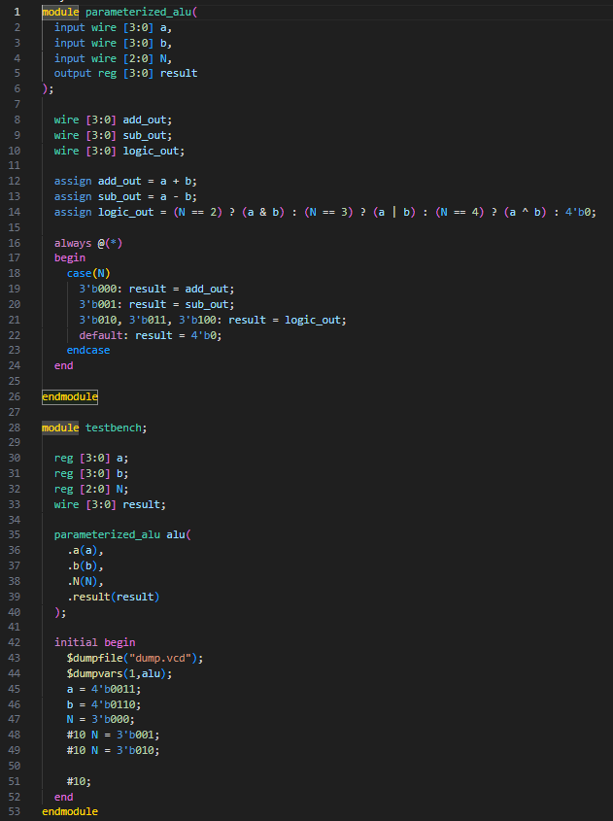

Output:
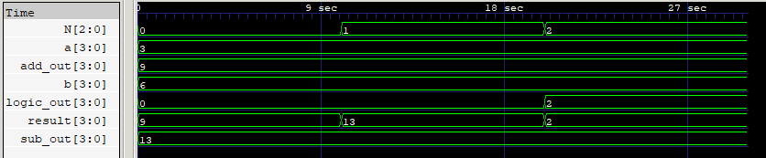

Conclusion:
In this lab session, we have implemented a simple parameterized ALU with 4 bit operands and 3 bit operations.

